Hatboro Residents Association-Membership Meeting

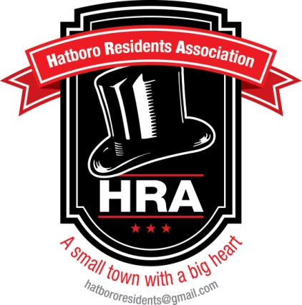

Agenda 03/25/14

- Call Meeting to Order

- Approval of the Minutes

- Treasurer’s Report

- Unfinished Business
- Farmer’s Market Update
- Farmer’s Market Committee
- Membership Drive Update
- Membership Committee

- New Business
- Community Garden
- New Facebook Name-Hatboro Residents’ Association
- Borough Council Meeting Update

- Questions/Comments

- Adjourn

