Hatboro Residents Association-Membership Meeting

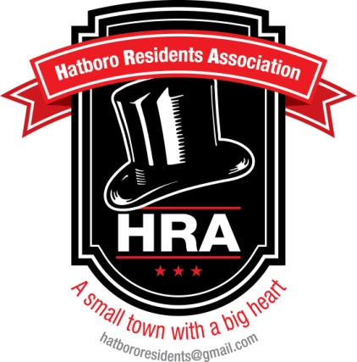

Agenda 02/25/14

- Call Meeting to Order

- Adoption of the Agenda

- Approval of the Minutes

- Treasurer’s Report

- Unfinished Business
- Public Relations/Advertising Efforts
- Borough Newsletter
- Farmer’s Market Update
- Clock Restoration Funding
- Special Committee Appointment (Leslie Jones-Chair of Membership Committee)
- Membership Drive
- HRA Contact with Chamber of Commerce re Tricentennial Planning
- Thank You Letter Chamber of Commerce
- Eaton Park Update
- Borough Council Meeting Update

- New Business
- Email alert 1 week prior- will include next meeting agenda and minutes from last membership meeting
- Contact information- New HRA email: hatbororesidents@gmail.com
(hra19040@gmail.com will remain in effect until April 1, 2014)
**Please note using the hatbororesidents@gmail.com is the appropriate form of communication and will be shared with all board members**
- Chief James Gardner-Emergency Management Protocol

- Questions/Comments

- Adjourn

