Hatboro Residents Association-Membership Meeting
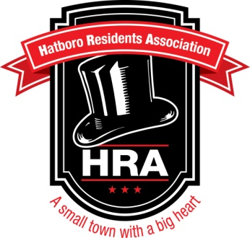
Agenda 05/27/14

- Call Meeting to Order

- Approval of the Minutes

- Treasurer’s Report

- Unfinished Business
- Farmer’s Market Update
- Membership Drive Update
- Borough Council Meeting Update
- Community Garden Update
- Clean Up Committee Update

- New Business
- HRA Stance on Historical Buildings/New Townhomes/Etc.
- Guest Speaker-Chuck Harting from Millbrook Historical Society
- Guest Speaker-Bill Tompkins from Borough Council

- Questions/Comments

- Adjourn

